

**“WATER LEVEL CONTROLLER”**

**A MINI PROJECT**

**REPORT**

*Submitted by*

**SANDEEP KUMAR REDDY G (1NH18EC046)**

***In partial fulfillment for the award of the degree of***

**BACHELOR OF ENGINEERING**

IN

**ELECTRONICS AND COMMUNICATION**

**ENGINERRING**



**DEPARTMENT OF ELECTRONICS AND COMMUNICATION ENGINEERING**

# CERTIFICATE

Certified that the mini project work entitled “**Water Level Controller**” carried out by **Sandeep Kumar Reddy.G (1NH18EC046)** bonafide students of Electronics and Communication Department, New Horizon College of Engineering, Bangalore.

The mini project report has been approved as it satisfies the academic requirements in respect of mini project work prescribed for the said degree.

Ms. Lipsa Dash Dr Sanjeev Sharma

Project Guide HOD ECE

------------------------- -------------------------

**External Viva**

Name of Examiner Signature with Date

1.

2.

**VISVESVARAYA TECHNOLOGICAL UNIVERSITY**



MINI PROJECT REPORT ON

**“WATER LEVEL CONTROLLER”**

SUBMITTED BY:

**Sandeep Kumar Reddy - 1NH18EC046**

Under the guidance of

**Mrs.Lipsa Dash**

Senior Assistant Professor,

Dept. of ECE, NHCE, Bengaluru.

# C:\Documents and Settings\Students\Local Settings\Temporary Internet Files\Content.Word\download (1).jpg

# NEW HORIZON COLLEGE OF ENGINEERING

(ISO-9001:2000 certified, Accredited by NAAC ‘A’, Autonomous college permanently affiliated to VTU)Outer Ring Road, Panathur Post, Near Marathalli, Bengaluru-560103

## NEW HORIZON COLLEGE OF ENGINEERING

## DEPARTMENT OF ELECTRONICS AND COMMUNICATION ENGINEERING



**CERTIFICATE**

Certified that the mini project work entitled “**Water Level Controller**” carried out by **SandeepKumarReddy.K(1NH18EC046)** bonafide students of Electronics and Communication Department , New Horizon College of Engineering, Bangalore.

The mini project report has been approved as it satisfies the academic requirements in respect of mini project work prescribed for the said degree.

Project Guide HOD ECE

------------------------- -------------------------

**External Viva**

Name of Examiner Signature with Date

1.

2.

**ACKNOWLEDGEMENT**

The satisfaction that accompany the successful completion of any task would be, but impossible without the mention of the people who made it possible, whose constant guidance and encouragement helped us succeed.

We thank **Dr. Mohan Manghnani**, Chairman of **New Horizon Educational Institution**, for providing necessary infrastructure and creating good environment.

We also record here the constant encouragement and facilities extended to us by **Dr.Manjunatha**, Principal, NHCE and **Dr. Sanjeev Sharma**, head of the department of Electronics and Communication Engineering. We extend sincere gratitude to them.

We sincerely acknowledge the encouragement, timely help and guidance to us by our beloved guide **Mrs.Lipsa Dash** to complete the project within stipulated time successfully.

Finally, a note of thanks to the teaching and non-teaching staff of electronics and communication department for their co-operation extended to us, who helped us directly or indirectly in this successful completion of mini project.

**Gourav D H (1NH18EC039)**

**Sandeep Kumar Reddy.K (1NH18EC046)**

**Dinesh.G (1NH18CV051)**

**G Vishnu Vadhan(1NH18EC035)**

**LIST OF FIGURES**

|  |  |  |
| --- | --- | --- |
| **FIGURE**  **No** | **FIGURE DESCRIPTION** | **Page**  **No** |
| 1 | Circuit diagram | 14 |
| 2 | NE 555 IC | 18 |
| 3 | Relay | 27 |
| 4 | Diode | 28 |
| 5 | Transistor | 29 |
| 6 | Water pump | 32 |
| 7 | Battery | 33 |
| 8 | Bread board | 34 |

### LIST OF TABLES

|  |  |  |  |
| --- | --- | --- | --- |
| **SL**  **No** | **Table**  **No** | **TABLE DESCRIPTION** | **Page**  **No** |
| 1 | 1 | Components | 9 |
| 2 | 2 | Problems | 14 |

**ABSTRACT**

Water level controller is used to control the water level in any water tank with help of water level controller we can automatically control the water level in the tank. We can save wastages of water using this design. As there are many designs but we are using 555 timer IC. Water level controller can maintain exact preset water level. It can be installed in homes, hotels and hospitals. The power used by this design is low and neglected. This circuit is compact easy to install and easy to move. To resolve this type of problems by using BC547 transistor and 555IC. As shown in the above block diagram gives the information about this particular water level controller. It consists of BC548 transistor, NE555 IC timer, 1N4007 diode, motor and a tank. When the input 9v-12v is given the project starts working. The input is given from power supply then the transistor will activate and through the relay the power is supplied to the IC. The output pin of the 555 IC is connected to the relay and the diode. Then the relay is maintained at a required level and the motor will start up by switching off When the motor is its ready to fill the tank by recognizing the sensors or water level in the tank. It depends on the level of the water. When the water is full, it automatically switches off.

**CHAPTER 1**

**INTRODUCTION**

A water level controller is a system which controls the level of water in any required tank. It basically reduces the human work of checking the water and filling it whenever it gets over and waiting till its full and turning it off, during this process, there might be some wastage of water. Hence to prevent this from happening and also to reduce human work, water level controller can be used, and it is a very simple and a very cost effective way to control the water level in any tank and also to prevent the wastage of water.

Water level controller plays an essential role in any water regulation system these days. Water level controllers are being extensively used by people to regulate water levels at various places. In most houses, water is first stored in an underground tank and from there it is pumped up to the overhead tank located on the roof. People generally switch on the pump when their taps go dry and switch off the pump when the overhead tank starts overflowing. This results in the unnecessary wastage and sometimes non-availability of water in the case of emergency. This water-level controller circuit makes this system automatic. It switches on the pump when the water level in the overhead tank goes low and switches it off as soon as the water level reaches a pre-determined level. It also prevents ‘dry run’ of the pump in case water level in underground tank goes below suction level.

Water is a gift from the gods and it shouldn’t be wasted. In most houses, we have water tanks that are filled for regular and daily use of water. We will switch the water motor on and keep track of the 30 to 90 minutes for the tank to fill up. Sometimes, the water will fill the tank too fast or too slow, depending on the amount of water remaining in the tank. The rest of the storage tank water will be wasted. Sometimes, you have to take a bath, but your water tank is empty. In order to resolve this issue, there is the automatic water level controller. There are a lot of ways to control your water levels. Here we discover one of the ways to regulate and control the level of water in your houses.

**CHAPTER 2**

**LITERATURE SURVEY**

**1.     Contact Water Level Controller**

Here a simple circuit to control the Water pumps. When the water level in the [overhead tank](https://www.edgefxkits.com/intelligent-overhead-tank-water-level-indicator-1803) exceeds the required level, the pump automatically turns off and stops the pumping process thus preventing the over flow of water. It uses a relay to cut off the power supply to the water pump.

The circuit is build using the following components:

* **CMOS IC CD4001**: It is a versatile 14 pin IC which contains 4 NOR gates. Each NOR gate has two inputs and one output. Thus the IC has 8 input pins and 4 output pins, one Vcc pin (connected to positive voltage supply) and one Vss (connected to negative supply). Its basic features include – Maximum supply voltage: 15V, Minimum supply voltage: 3V, Maximum speed of operation: 4MHz. It can be used in tone generators, metal detectors etc.
* **Transistor BC547**: It is a NPN bipolar junction transistor and it is used mainly for amplification and switching purpose. Its features include maximum current gain of 800.It is used in CE configuration when used as an amplifier.
* **Battery**: A DC supply of 9V is given through a battery to power up the circuit.

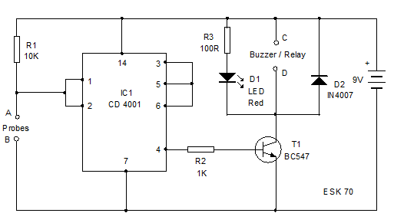

The circuit uses a CMOS IC CD 4001 / 4011 to drive the relay. Its input gate 1 is used to connect the probe to detect the water level. One probe is connected to the gate 1 of the IC and the other probe to the ground. When the probe A connected to the gate 1 of IC is floating, the input of gate 1 remains high and the output pin 4 goes high and the relay driver transistor conducts. The relay will be activated. The power supply of the water pump is connected through the common and the NO contacts of the relay so that when the relay turns on, water pump works. LED indicates the working of the relay. When the water level rises and makes contact with the probes A and B, output of IC turns low and the relay de-energizes to stop the pumping.

Initially when A and B are not connected, i.e. water level is low, the input pin1 of the IC is at logic high and according to NOR gate truth table, the output at pin3 will be at logic low. Since pin3 is shorted to pins 5 and 6, hence the input to other NOR gate will be logic low signals. This gives a logic high signal to the corresponding output pin 4. As current flows through the resistor to the base of transistor, it starts conducting and acts as a closed switch. The relay connected to the collector of the transistor gets energized and the NO contacts get connected to the common contact and the water pump gets power supply from the mains and starts working.

Now when water level rises in the tank rises such that probes A and B are connected through water, current flows through them (As water is a conductor) and the pins 1 and 2 are connected through A and B to the negative supply of the battery.

The output pin 3 is thus, at logic high level, causing the input pins of the other NOR gate to be at logic high level and thus the corresponding output pin4 is at logic low level. The transistor gets cut off due to lack of bias current and the relay gets correspondingly de-energized and the power supply to the [water tank](https://www.edgefxkits.com/tank-water-level-controller) gets cut off.

**2.     Contactless Water Level Controller**

Apart from the technique discussed above, there can be another way to control water level in the tank by sensing it using Ultrasonic technique.  Unlike the previous method, this does not requires any [contact with the water tank](https://www.edgefxkits.com/contactless-liquid-level-controller).

The system consists of the following parts

1. A Regulated DC power supply to convert the AC supply to regulated DC voltage using bridge rectifiers and filters.
2. An ultrasonic Module consisting of an ultrasonic transmitter and a receiver to sense the water level condition of the tank.
3. A microcontroller which acts as a control unit.
4. A transistor and a MOSFET unit which forms the switching unit
5. A relay to control application of current to the pump
6. A Pump which is the load

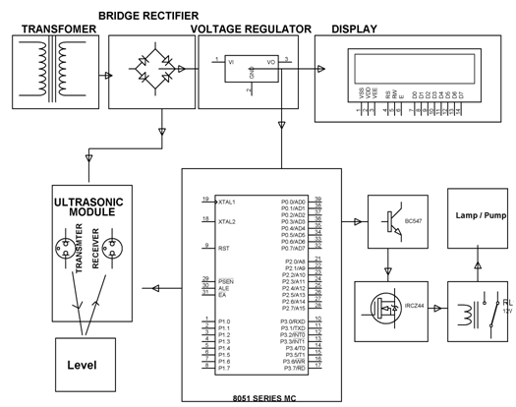Water Level

The ultrasonic sensor senses the level of water in the tank by transmitting ultrasonic signals towards the tank. The water in the tank reflects back the ultrasonic signals, which are received by the receiver. The ultrasonic or the sound signal received is converted to electric signal pulses which are applied to the Microcontroller. These pulses denote the level of water in the tank. As the water level decreases below certain level, the ultrasonic module gives an indication through the electric signal and the Microcontroller accordingly drives the transistor to off condition, which in turn causes the MOSFET to be switched on and accordingly the relay gets energized and the pump is switched on. In case the water level is above the threshold level, the Microcontroller accordingly switches off the relay through the transistor and MOSFET arrangement, so as to switch off the pump.

**3.     A Digital Water Level Indicator**

This system is used only to sense the level of water in a tank and display the reading on a 7 segment display.

Here a circuit board consisting of a parallel arrangement of conducting wires is placed in the tank. These wires serve as input to the Priority Encoder which generates a BCD output based on the input readings.  The Priority Encoder drives a set of transistors which in turn provide input to the BCD to 7 segments Decoder which uses the BCD signal to drive the 7 segment LED display.

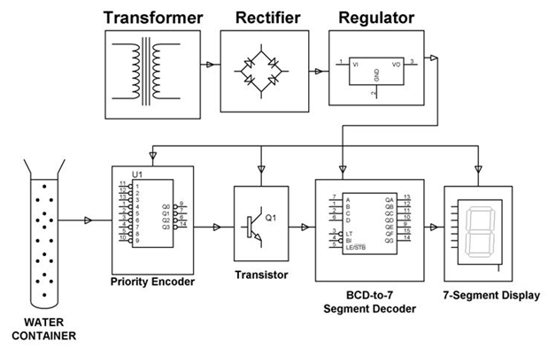Intelligent Overhead Tank When the input unit is placed in the water tank, current flows through the wires immersed in water and accordingly the corresponding number of inputs is in high logic state. The Encoder receives this input and based on the priority level of the inputs, gives a digital output code corresponding to the input with highest priority.

Thus if current flows through all the wires, i.e. the tank is full; the output code will correspond to the highest level. Here the input unit or the scale is divided into 10 levels from 0 to 9. Incase all the inputs to the Encoder are in high state, the output is also a high logic signal which drives all the transistors to ON condition, so that all the inputs to the BCD to 7 segment Decoder are in low logic state. The BCD to 7 segment Decoder simply acts as an inverter and thus gives a high logic signal in all its output and thus the highest level of 9 is displayed on the Display.

Rawjgw;rojgn;RH

**CHAPTER 3**

**PROPOSED METHODOLOGY**

In this project, the 555 timer IC acts as the heart of the project. The 555 timer IC is the sole controller for the power supply to all the components in the circuit. The IC is powered through a 9V battery. The trigger and the threshold pins of the IC are used to determine the water level and initiate the output pin. When the water goes below the threshold pin, the output is given and the motor is turned on. Since the output is very low, a transistor is used to amplify the output which is given to a relay. This relay is used to run the motor with another power supply given to the relay as per the motor requirements. And once the water touches the threshold pin, the output becomes zero and the supply to the relay is stopped and the motor turns off. For these trigger and threshold pins to work, a power supply is given to the water which acts as an input for the respective pins.

Fig 1

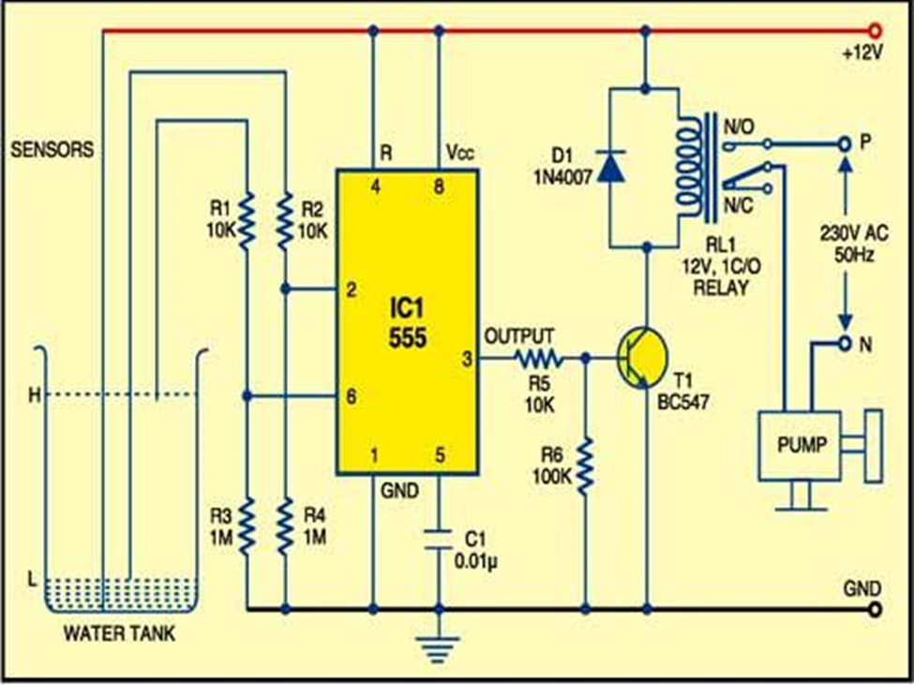

**CHAPTER 3.1**

**COMPONENTS REQUIRED**

|  |  |  |  |
| --- | --- | --- | --- |
| S.No. | Required Components | Remarks | Quantity |
| 1 | IC’s | NE555 | 1 |
| 2 | Transistor | BC547 NPN transistor | 1 |
| 3 | Diode | 1NH4001 | 1 |
| 4 | Water pump | 3-6 V  80-120 L/H  DC Magnetic driving | 1 |
| 5 | Resistor | Quarter watt | 10k ohm - 3  100k Ohm – 1  1M Ohm – 2 |
| 6 | Capacitor | Ceramic | 0.01uf – 1 |
|  |  |  |  |
| 7 | Relay | 12v 150 Ohm | 1 |
|  |  |  |  |

**CHAPTER 4**

**PROJECT DESCRIPTION**

In this project, we use a NE555 timer IC to do the core operation of controlling the level of water, and to this IC we give connections according to its pin numbers to make our operations work. How Does It Work We know the property of 555 timer IC, i.e.its output goes HIGH when voltage at the second pin(trigger pin) is less than 1/3 Vcc. Also we can reset back the IC by applying a LOW voltage at the 4th pin (Reset pin). In the above circuit3 wires are dipped in water tank. Let us define two water levels- Bottom (Low) level and Top (Up) level. One of the wire or probe is from.

The probe from bottom level is connected to the trigger (2nd) pin of 555 IC. So the voltage at 2nd pin is Vcc when it is covered by water. When water level goes down, the 2nd pin gets disconnected (untouched) from water i.e. voltage at the trigger pin becomes less than Vcc. Then the output of 555 becomes high. While the water level rises, the top level probe is covered by water and the transistor becomes ON. Its collector voltage goes to Vce=0.2. The low voltage at the fourth pin resets the IC. So the output of 555 becomes 0 volt. Hence the motor will turn of automatically. For simple demonstration of this project we can use a DC motor directly at the output of 555 instead of relay. For practical implementation we must use a relay. Rating of relay is chosen according to the load (motor). 32A relay is best suited for domestic applications.

The input section has a coil which generates magnetic field when a small voltage from an electronic circuit is applied to it. This voltage is called the operating voltage. Commonly used relays are available in different configuration of operating voltages like 6V, 9V, 12V, 24V etc. The output section consists of contactors which connect or disconnect mechanically. In a basic relay there are three contactors: normally open (NO), normally closed (NC) and common (COM). At no input state, the COM is connected to NC. When the operating voltage is applied the relay coil gets energized and the COM changes contact to NO.

The transistor terminals require a fixed DC voltage to operate in the desired region of its characteristic curves. This is known as the biasing. For amplification applications, the transistor is biased such that it is partly on for all input conditions. The input signal at base is amplified and taken at the emitter. BC548 is used in common emitter configuration for amplifiers. The voltage divider is the commonly used biasing mode. For switching applications, transistor is biased so that it remains fully on if there is a signal at its base. In the absence of base signal, it gets completely off.

**CHAPTER 4.1**

**HARDWARE DESCRIPTION**

**NE555 IC pin diagram :**

This IC contains an SR flip flop as shown in the figure

Fig 2

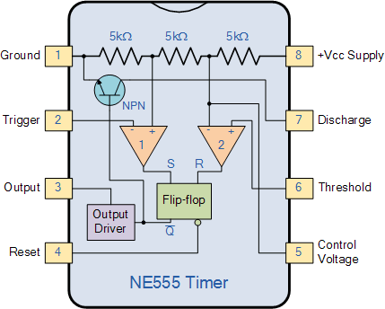

## Some important features of the 555 timer:

555 timer is used in almost every electronic circuit today. For a 555 timer working as a [flip flop](https://electronicsforu.com/resources/learn-electronics/flip-flop-rs-jk-t-d) or as a multi-vibrator, it has a particular set of configurations. Some of the major features of the 555 timer would be,

* It operates from a wide range of power ranging from +5 Volts to +18 Volts supply voltage.
* Sinking or sourcing 200 mA of load current.
* The external components should be selected properly so that the timing intervals can be made into several minutes along with the frequencies exceeding several hundred kilohertz.
* The output of a 555 timer can drive a transistor-transistor logic (TTL) due to its high current output.
* It has a temperature stability of 50 parts per million (ppm) per degree Celsius change in temperature which is equivalent to 0.005 %/ °C.
* The duty cycle of the timer is adjustable.
* Also, the maximum power dissipation per package is 600 mW and its trigger and reset inputs has logic compatibility.

## Pin diagram and description

|  |  |  |
| --- | --- | --- |
| **Pin** | **Name** | **Purpose** |
| 1 | GND | Ground reference voltage, low level (0 V) |
| 2 | TRIG | The OUT pin goes high and a timing interval starts when this input falls below 1/2 of CTRL voltage (which is typically 1/3 *V*cc, CTRL being 2/3 *V*cc by default if CTRL is left open). In other words, OUT is high as long as the trigger low. Output of the timer totally depends upon the amplitude of the external trigger voltage applied to this pin. |
| 3 | OUT | This output is driven to approximately 1.7 V below +*V*cc, or to GND. |
| 4 | RESET | A timing interval may be reset by driving this input to GND, but the timing does not begin again until RESET rises above approximately 0.7 volts. Overrides TRIG which overrides threshold. |
| 5 | CTRL | Provides “control” access to the internal voltage divider (by default, 2/3 *V*cc). |
| 6 | THR | The timing (OUT high) interval ends when the voltage at threshold is greater than that at CTRL (2/3 *V*cc if CTRL is open). |
| 7 | DIS | Open collector output which may discharge a capacitor between intervals. In phase with output. |
| 8 | *V*cc | Positive supply voltage, which is usually between 3 and 15 V depending is variable |

The timer IC 555 was introduced around 1971 by the company Signetics under the name SE555 / NE555 and was called "The Time Machine IC". It offered circuit designers a relatively inexpensive, stable and easy-to-use integrated circuit for monostable and astable applications. Since this device was first marketed, many unique and innovative circuits have been developed and presented in various commercial, professional and leisure publications. Over the past decade, some manufacturers have stopped making these timers for reasons of competition or other reasons. However, other companies, such as NTE (a sub-division of Philips) have resumed their activities where some have left.

Although the CMOS version of this IC, such as the Motorola MC1455, is primarily used, the standard type is still available, but many enhancements and variations have been made to the circuits. But all types are compatible with pin plugs. In this tutorial, the 555 timer is examined in detail, as are its uses, either alone or in combination with other semiconductor devices. This timer uses a labyrinth of transistors, diodes and resistors and, for this complex reason, a more simplified (but precise) block diagram is used to explain the internal organization of 555. The 555, in fig. 1 and FIG. 2 above, is available in two cases, either the round metal housing called "T", or the 8-pin DIP housing better known, "V". About 20 years ago, the type of canister was almost standard (SE / NE types). The 556 timer is a 555 dual version and comes in a 14-pin DIP package, the 558 is a quad version with four 555s also in a 14-pin DIP package.

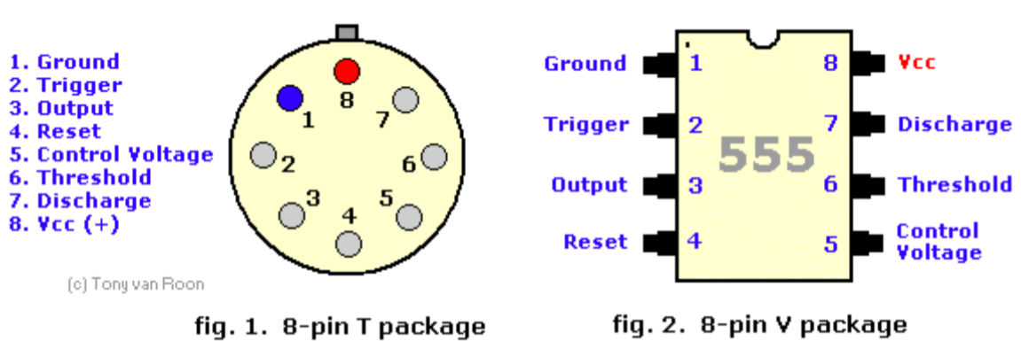Pin 1 (ground): The ground (or common) pin is the most negative power potential of the device, which is normally connected to the common (ground) circuit when operating from positive supply voltages.

Pin 2 (trigger): This pin is the input of the lower comparator and is used to adjust the latch, which makes the output high. This is the beginning of the time sequence in the monostable operation. The shot is obtained by taking the pin up and down with a voltage of 1/3 V + (or, in general, half of the voltage appearing on pin 5). The action of the activation input is level sensitive, allowing the use of slow change rate waveforms, as well as pulses, as activation sources. The trigger pulse must be shorter than the time interval determined by external R & C. If this pin remains low longer, the output will remain high until the trigger input increases again. A caution to observe with the trigger input signal is that it should not be less than 1/3 V + for a longer period than the synchronization cycle. If allowed, the timer will be reactivated at the end of the first output pulse. Therefore, when the timer is used in monostable mode with input pulses longer than the desired output pulse width, the input trigger must be effectively shortened by differentiation. The minimum pulse width allowed for activation depends to some extent on the pulse level, but in general if greater than 1uS (micro-second), the activation will be reliable. A second precaution concerning the trigger input refers to the storage duration in the lower comparator. This part of the circuit may have normal stopping delays of several microseconds after activation; that is, the lock may still have an activation input during this period after the activation pulse. In practice, this means that the minimum monostable output pulse width must be of the order of 10 μS in order to avoid possible double activation due to this effect. The voltage range that can safely be applied to the trip pin is between V + and ground. A DC current, called the tripping current, must also flow from this terminal to the external circuit. This current is usually 500nA (nano-amp) and will set the upper limit of allowable resistance of pin 2 to earth. For an astable configuration operating at V + = 5 volts, this resistance is 3 megaohms; It can be higher for a higher level of V +.

Pin 3 (output): output 555 is from a high current totem stage consisting of transistors Q20 to Q24. Transistors Q21 and Q22 provide a drive for source-type loads, and their Darlington connection provides a high output voltage of about 1.7 volts less than the V + power level used. Transistor Q24 offers the possibility of absorbing the current for low state loads called V + (as typical TTL inputs). The transistor Q24 has a low saturation voltage, which allows it to interact directly with a good noise margin when it performs the current reduction logic. However, the exact output saturation levels vary considerably with the supply voltage, for both high and low states. At a V + of 5 volts, for example, the low state Vce (sat) is typically 0.25 volts at 5 mA. However, when running at 15 volts, it can absorb 200 mA if a 2 volt output voltage level is allowed (the power dissipation must be taken into account in this case, of course). The high state level is typically 3.3 volts at V + = 5 volts; 13.3 volts at V + = 15 volts. The rise and fall times of the output waveform are quite fast, the typical switching times are 100nS. The state of the output pin will always reflect the opposite of the logic state of the latch, which can be seen by examining FIG. 3. Since the lock itself is not directly accessible, this relation can be better explained in terms of the activation activation lock conditions. To activate the output in the high state, the activation input is momentarily taken from a higher level to a lower level. [see "Pin 2 - Trigger"]. This causes locking and high output. The performance of the lower comparator is the only way to set the output high. The output can return to a low state by raising the threshold from a lower level to a higher level [see "Pin 6 - Threshold"], which resets the latch. The output can also be reduced by bringing the reset to a low state near the ground [see "Pin 4 - Reset"]. The output voltage available on this pin is approximately equal to the Vcc applied to pin 8 minus 1.7Vs.

Pin 4 (reset): This pin is also used to reset the latch and return the output to a low state. The threshold level of the reset voltage is 0.7 volts and a 0.1 mA dissipation current of this pin is required to restart the device. These levels are relatively independent of the V + level of operation; Thus, the reset input is compatible with TTL for any supply voltage. The reset input is a primary function. that is, it will force the output to a low state regardless of the state of the other inputs. Therefore, it can be used to prematurely terminate an output pulse, to block oscillations from "on" to "off", etc. The delay time between the restart and the output is generally of the order of 0.5 μS and the minimum width of the reset pulse is 0.5 μS. However, none of these numbers are guaranteed and may vary from manufacturer to manufacturer. In summary, the reset pin is used to reset the latch that controls the state of output pin 3. The pin is activated when a voltage level between 0 and 0.4 volts is applied to the pin. The reset pin will force the output to a low level, regardless of the state in which the other inputs of the flip-flop are located. When not in use, it is recommended to connect the reset input to V + in order to avoid the possibility of false restart.

Pin 5 (control voltage): This pin allows direct access to the 2/3 V + voltage division point, the reference level of the upper comparator. It also allows indirect access to the lower comparator because there is a 2: 1 splitter (R8 - R9) from this point to the lower comparator reference input, Q13. The use of this terminal is a user option, but it allows extreme flexibility by allowing the modification of the period, the restart of the comparator, etc. When timer 555 is used in a voltage controlled mode, its voltage operation varies from about 1 volt less than V + to 2 volts of mass (although this is not guaranteed). Voltages may safely be applied outside these limits, but must be limited within the V + and ground limits for reasons of reliability. By applying a voltage to this pin, it is possible to vary the duration of the device independently of the RC network. The control voltage can vary from 45 to 90% of the Vcc in monostable mode, which allows the output pulse width to be controlled independently of RC. When used in astable mode, the control voltage can vary from 1.7 V to full VDC. Variable voltage in astable mode will produce a modulated frequency (FM) output. If the control voltage pin is not used, it is recommended to ground it with a capacitor of about 0.01uF (10nF) for noise immunity because it is an input comparison. This fact is not evident in many 555 circuits since I have seen many circuits with "no-pin-5" connected to anything, but this is the proper procedure. The small ceramic lid can eliminate false activations.

Pin 6 (threshold): Pin 6 is an input of the upper comparator (the other is pin 5) and is used to reset the latch, resulting in low output. The reset through this terminal is made by taking the bottom terminal to a voltage of 2/3 V + (the normal voltage on pin 5). The action of the threshold pin is level sensitive, which allows slow rate of change waveforms. The voltage range that can safely be applied to the threshold pin is between V + and ground. A direct current, called the current threshold, must also reach this terminal from the external circuit. This current is generally 0.1 μA and will define the upper limit of total resistance allowed from pin 6 to V +. For any synchronization setting that operates at V + = 5 volts, this resistance is 16 MΩ. For operation at 15 volts, the maximum resistance value is 20 MΩ.

Pin 7 (discharge): this pin is connected to the open collector of an NPN transistor (Q14), whose emitter is grounded, so that when the transistor is activated, pin 7 is actually short-circuited to the mass. Generally, the sync capacitor is connected between pin 7 and ground and is discharged when the transistor is turned on. The state of attack of this transistor has a synchronization identical to that of the output stage. It is "on" (low resistance to earth) when the output is low and "off" (high resistance to earth) when the output is high. In the monostable and astable time modes, this transistor switch is used to ground the appropriate nodes of the synchronization network. The saturation voltage is generally less than 100 mV (millivolts) for currents of 5 mA or less, and the leakage in the off state is approximately 20 nA (however, these parameters are not specified by all manufacturers) . The maximum collector current is internally limited by design, thus eliminating capacitor size restrictions due to the maximum discharge of the pulse current. In some applications, this open-collector output can be used as an auxiliary output terminal, with a current-dissipating capacity similar to that of the output (pin 3).

Pin 8 (V +): Pin V + (also called Vcc) is the positive power supply terminal of the timer CI 555. The operating voltage supply range of the 555 is between +4.5 volts (minimum) and +16 volts (maximum). It is specified for operation between +5 volts and +15 volts. The device will operate essentially in the same way in this voltage range without changing the period. In fact, the most significant operating difference is the capacity of the output inverter, which increases for both the current and voltage ranges as the supply voltage increases. The sensitivity of the time interval to the variation of the supply voltage is low, typically 0.1% per volt. T here are special and military devices operating at voltages up to 18 V.

**Gsnnanaegnteh**

**T h th wh**

**Wrhrhgrfsavgarq cvzas**

**Safvbsaethaszcfethcszfeth**

**Safcets vethcsgzv etsc fethscz**

**asfvbsgtasqfeGsnnanaegnteh**

**T h th wh**

**Wrhrhgrfsavgarq cvzas**

**Safvbsaethaszcfethcszfeth**

**Safcets vethcsgzv etsc fethscz**

**Asfvbsgtasqfefsethscf efsethscf ethc**

**Relay:**

A relay is classified into many types, a standard and generally used relay is made up of electromagnets which in general used as a switch. the signal received from one side of the device controls the switching operation on the other side. So relay is a switch which controls (open and close) circuits electromechanically. The main operation of this device is to make or break contact with the help of a signal without any human involvement in order to switch it ON or OFF. It is mainly used to control a high powered circuit using a low power signal.

Fig 3

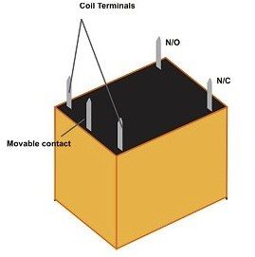

**Diode:**

**Diode**, an electrical component that allows the flow of current in only one direction. In circuit diagrams, a diode is represented by a triangle with a line across one vertex. The most common type of diode uses a p n junction. In this type of diode, one material (*n*) in which electrons are charge carriers abuts a second material (*p*) in which holes (places depleted of electrons that act as positively charged particles) act as charge carriers. At their interface, a depletion region is formed across which electrons diffuse to fill holes in the *p*-side. This stops the further flow of electrons. When this junction is forward [biased](https://www.merriam-webster.com/dictionary/biased) (that is, a positive voltage is applied to the *p*-side), electrons can easily move across the junction to fill the holes, and a current flows through the diode. When the junction is reverse biased (that is, a negative voltage is applied to the *p*-side), the depletion region widens and electrons cannot easily move across. The current remains very small until a certain voltage (the breakdown voltage) is reached and the current suddenly increases.

Fig 4

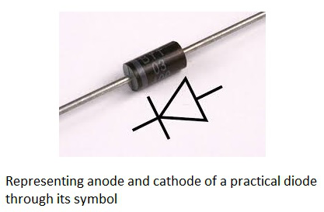

**Transistor** :

There are typically three electrical leads in a transistor, called the emitter, the collector, and the base. An electrical signal applied to the base (or gate) influences the semiconductor material’s ability to conduct electrical current, which flows between the emitter and collector in most applications. A voltage source such as a battery drives the current, while the rate of current flow through the transistor at any given moment.

* Driver Modules like Relay Driver, LED driver
* Amplifier modules like Audio amplifiers, signal Amplifier

Fig 5

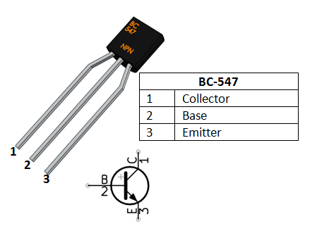

Earlier, the critical and important component of an electronic device was a vacuum tube; it is an electron tube used to [control electric current](https://www.edgefxkits.com/smooth-start-of-a-single-phase-induction-motor). The vacuum tubes worked but they are bulky, require higher operating voltages, high power consumption, yield lower efficiency and cathode electron-emitting materials are used up in operation. So, that ended up as heat which shortened the life of the tube itself. To overcome these problems, John Bardeen, Walter Brattain and William Shockley were invented a transistor at Bell Labs in the year of 1947. This new device was a much more elegant solution to overcome many of the fundamental limitations of vacuum tubes.

Transistor is a semiconductor device that can both conduct and insulate. A transistor can act as a switch and an amplifier. It converts audio waves into electronic waves and resistor, controlling electronic current. Transistors have very long life, smaller in size, can operate on lower voltage supplies for greater safety and required no filament current. The first transistor was fabricated with germanium. A transistor performs the same function as a vacuum tube triode, but using semiconductor junctions instead of heated electrodes in a vacuum chamber. It is the fundamental building block of modern electronic devices and found everywhere in modern electronic systems.

### Transistor Basics:

A transistor is a three terminal device. Namely,

* Base: This is responsible for activating the transistor.
* Collector: This is the positive lead.
* Emitter: This is the negative lead

NPN transistor

N-P-N transistor consisting a layer of P-doped semiconductor between two layers of N-doped material. By amplifying current the base we get the high collector and emitter current.

That is when NPN transistor is ON when its base is pulled low relative to the emitter. When the transistor is in ON state, current flow is in between the collector and emitter of the transistor. Based on minority carriers in P-type region the electrons moving from emitter to collector. It allows the greater current and faster operation; because of this reason most bipolar transistors used today are NPN.

**WATER PUMP MOTOR:**

Micro DC 3-6V Micro Submersible Pump Mini water pump For Fountain Garden Mini water circulation System DIY project. This is a low cost, small size Submersible Pump Motor which can be operated from a 3 ~ 6V power supply. It can take up to 120 liters per hour with very low current consumption of 220mA. Just connect tube pipe to the motor outlet, submerge it in water and power it. Make sure that the water level is always higher than the motor. Dry run may damage the motor due to heating and it will also produce noise.

**Specifications:-**

Operating Voltage : 3 ~ 6V

Operating Current : 130 ~ 220mA

Flow Rate : 80 ~ 120 L/H

Maximum Lift : 40 ~ 110 mm

Continuous Working Life : 500 hours

Driving Mode : DC, Magnetic Driving

Material : Engineering Plastic

Outlet Outside Diameter : 7.5 mm

Outlet Inside Diameter : 5 mm

Fig 6

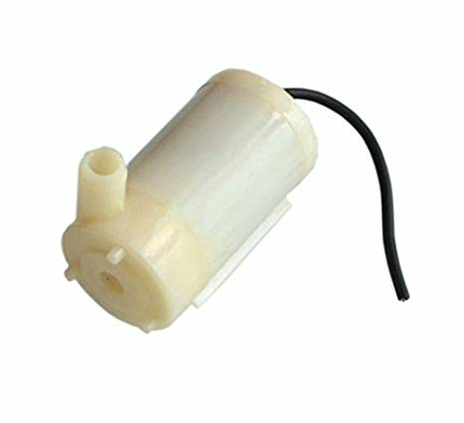

**POWER SUPPLY:**

A power supply is a device that supplies electric power to a electric load .The term is most commonly referred to electric power converts that converts one form of electrical energy to another ,though it may also refer to that convert another form of energy ( mechanical chemical, solar) to electrical energy . The regulated power supply is that controls the output voltage or current to a specific value ;the controlled value is held nearly .

Fig 7

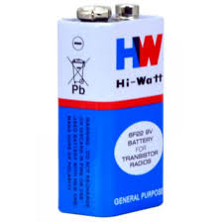

RjadVKLnb’RPNBalkrnVaLKVAL.WGNRVLqnghqrilhgQEIJGQp’;gjQP’EIGR’P;INGAQNRPVG;INAWNVINAR

**BREADBOARD:**

A breadboard is a solderless device for temporary prototype with electronics and test circuit designs. Most electronic components in electronic circuits can be interconnected by inserting their leads or terminals into the holes and then making connections through wires where appropriate.

Fig 8

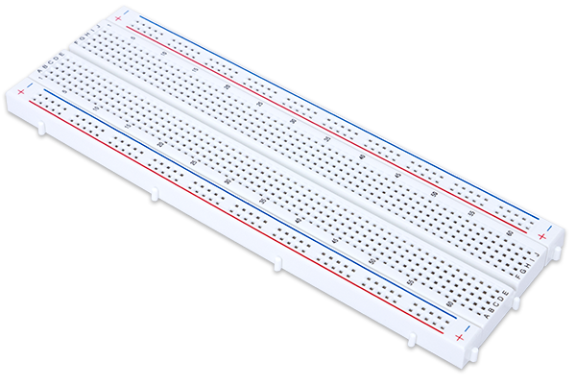

**RESULT**

The project works successfully. Whenever the water level goes low, the motor gets turned on automatically and the water fills up to the mark. The water level is always maintained at the top, constantly. Even as the water level in the tank decreases a little the motor is turned on and the water keeps filling continuously.

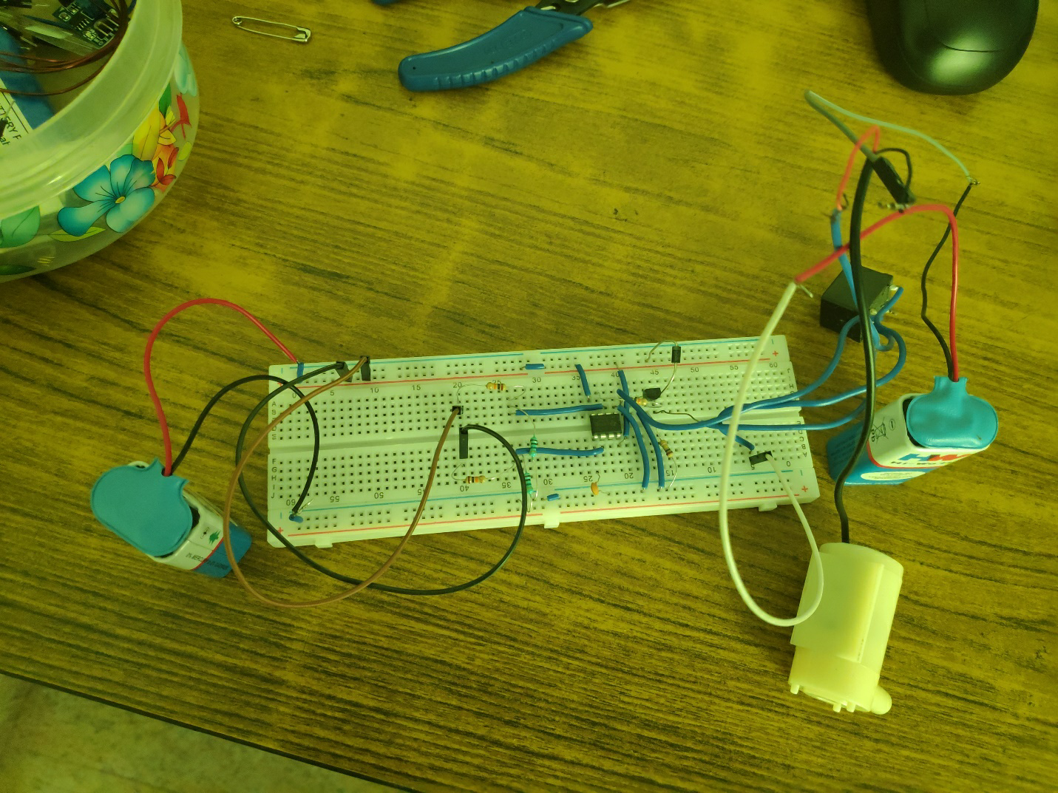

**CHAPTER 6**

**CONCLUSION AND FUTURE SCOPE**

In these days, when Earth's reserve of consumable water is decreasing every moment, every drop has its value. Water level controller is a simple yet effective way to prevent wastage of water. Its simplicity in design and low cost components make it an ideal piece of technology for the common man.

Thus the automatic water level controller is a big boon as concerned with the house hold applications as well as other water saving purposes including agricultural sector and industries. Based on the survey result, it is found that the automatic water level controller has a rising demand and it is a good asset from the electronics perspective.

Hence we conclude that this system is very beneficial in rural as well as urban areas. o It helps in the efficient utilization of available water sources. o If used on a large scale, it can provide a major contribution in the conservation of water for us and the future generations.

Advantages

Automatic water level controller is used to automatically fill the overhead tank as and when it gets empty and monitor the water level in it. o Automatic water level controller is simple and easy to install. o Automatic water level controller has low maintenance. o Automatic water level controller has compact and elegant design. o Automatic water level controller is fully automatic. o Automatic water level controller with its precise working saves water and the motor enerry. r Automatic water level controller avoids the seepage of walls and roofs when the tank overflows. e Automatic water level controller is ideal as it is difficult to access overhead tanks. Automatic water level controller has safe operation of motor/pump within permissible voltage limits.

Disadvantages

It is a passive electrical system and hence it requires continuous power supply.

**REFERENCES**

Grob’s Basic Electronics

<https://electronicsforu.com/electronics-projects/automatic-water-level-controller>

<https://dir.indiamart.com/impcat/automatic-water-level-controller.html>

<https://waterlevelcontrols.com/>

<http://www.water-level-controller.com/>

<http://www.circuitstoday.com/water-level-controller>

<https://electronicsforu.com/resources/learn-electronics/555-timer-working-specifications>

<https://en.wikipedia.org/wiki/555_timer_IC>

<https://www.jameco.com/Jameco/workshop/TechTip/555-timer-tutorial.html>

<https://www.edgefx.in/555-timer-ic-introduction-and-working-with-operating-modes/>

<https://www.instructables.com/id/555-Timer/>